Java Servlet

Lab Task 1:Create a Java Servlet (DisplayMessageServlet)that outputs a static message.

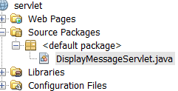

2: Configure the servletusing the @WebServlet annotation or the web.xml deployment descriptor.

import java.io.IOException;

import java.io.PrintWriter;

import javax.servlet.ServletException;

import javax.servlet.annotation.WebServlet;

import javax.servlet.http.HttpServlet;

import javax.servlet.http.HttpServletRequest;

import javax.servlet.http.HttpServletResponse;

@WebServlet("/displayMessage")

public class DisplayMessageServlet extends HttpServlet {

protected void doGet(HttpServletRequest request, HttpServletResponse response)

throws ServletException, IOException {

response.setContentType("text/html");

PrintWriter out = response.getWriter();

out.println("<html><body>");

out.println("<h1>Welcome to the Java Servlet Lab!</h1>");

out.println("</body></html>");

}

}

Deployment Descriptor (web.xml) (if not using annotations):

<web-app xmlns="http://java.sun.com/xml/ns/javaee"

 version="3.0">

 <servlet>

 <servlet-name>DisplayMessageServlet</servlet-name>  <servlet-class>com.example.DisplayMessageServlet</servlet-class>  </servlet>

 <servlet-mapping>

 <servlet-name>DisplayMessageServlet</servlet-name>

 <url-pattern>/displayMessage</url-pattern>

 </servlet-mapping>

</web

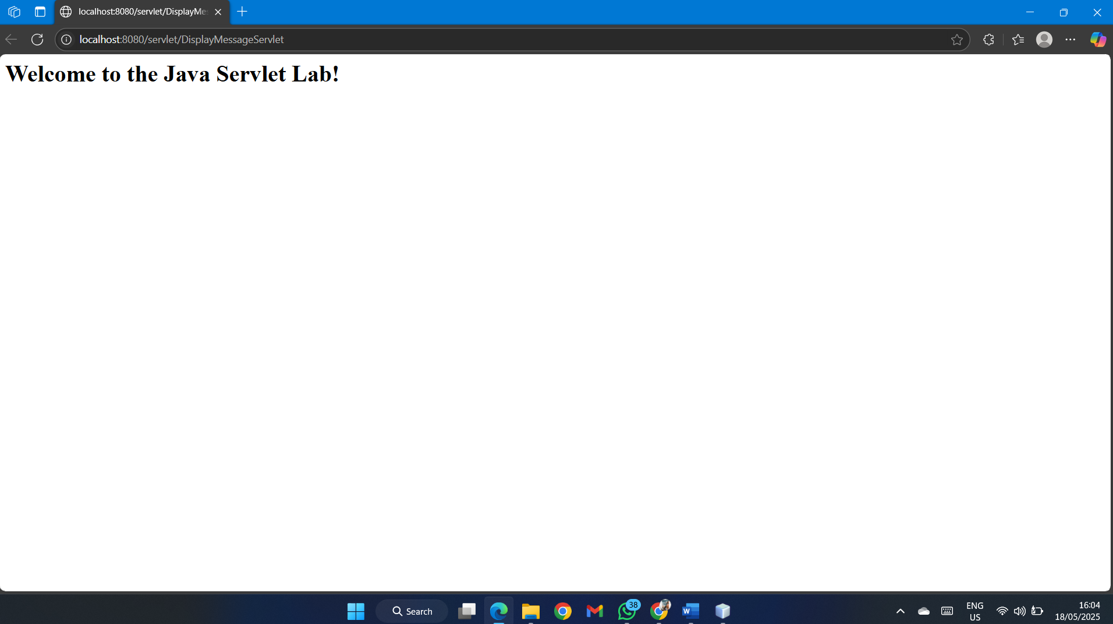

Lab Task 2: Get User Input from Form and Display

<!DOCTYPE html>

<html>

<head>

<title>Input Form</title>

</head>

<body>

 <form action="getUserInput" method="POST">

Name: <input type="text" name="username" required><br>  <input type="submit" value="Submit">

 </form>

</body>

</html>

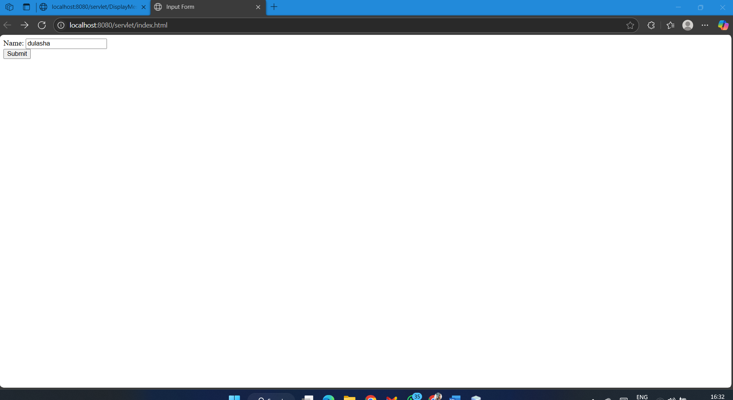

Servlet Code (GetUserInputServlet.java):

import java.io.IOException;

import java.io.PrintWriter;

import javax.servlet.ServletException;

import javax.servlet.annotation.WebServlet;

import javax.servlet.http.HttpServlet;

import javax.servlet.http.HttpServletRequest;

import javax.servlet.http.HttpServletResponse;

@WebServlet("/getUserInput")

public class GetUserInputServlet extends HttpServlet {

@Override

protected void doPost(HttpServletRequest request, HttpServletResponse response) throws ServletException, IOException {

String username = request.getParameter("username");

response.setContentType("text/html");

PrintWriter out = response.getWriter();

out.println("<html><body>");

out.println("<h1>Hello, " + username + "!</h1>");

out.println("</body></html>");

}

}

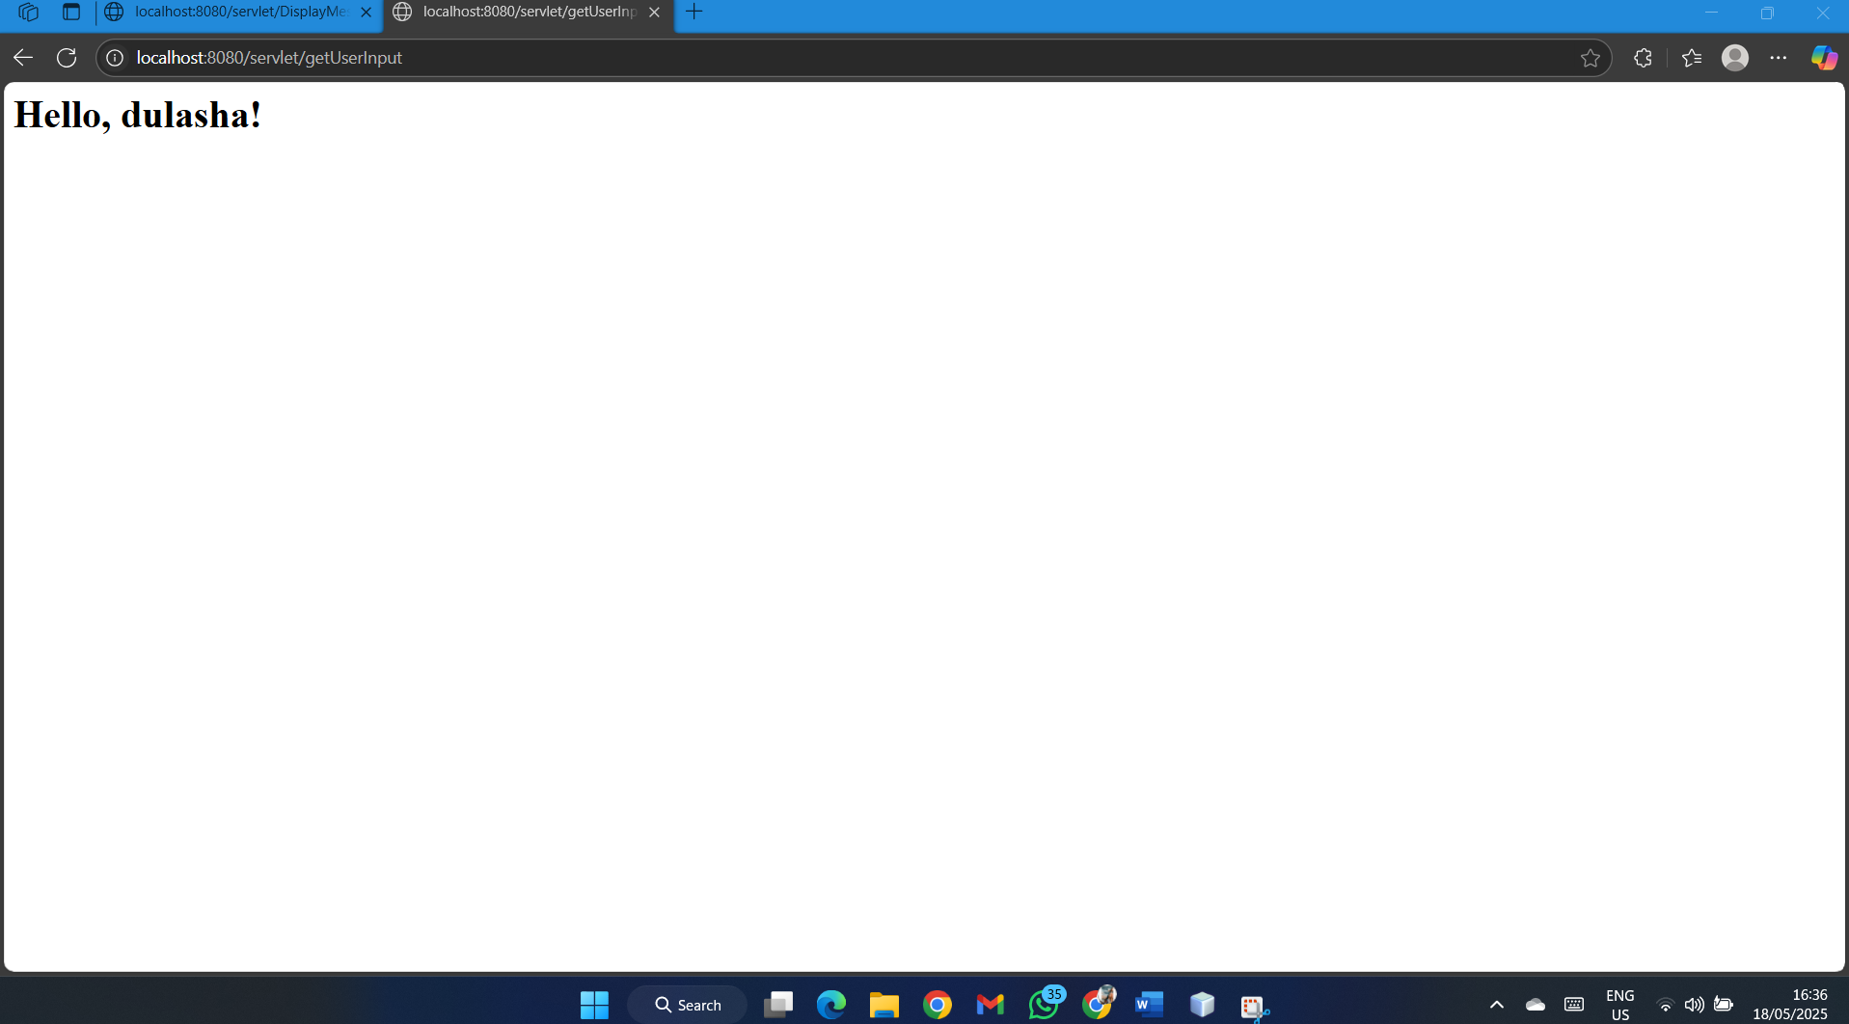

Lab Task 3: Get Multiple Inputs, Perform Calculation, and Display Result

**Create an HTML form** to take inputs for two numbers.

<!DOCTYPE html>

<html>

<head>

<title>Sum Calculator</title>

</head>

<body>

  <form action="calculateSum" method="POST">

First Number: <input type="number" name="num1" required><br>  Second Number: <input type="number" name="num2" required><br>  <input type="submit" value="Calculate Sum">

 </form>

</body>

</html>

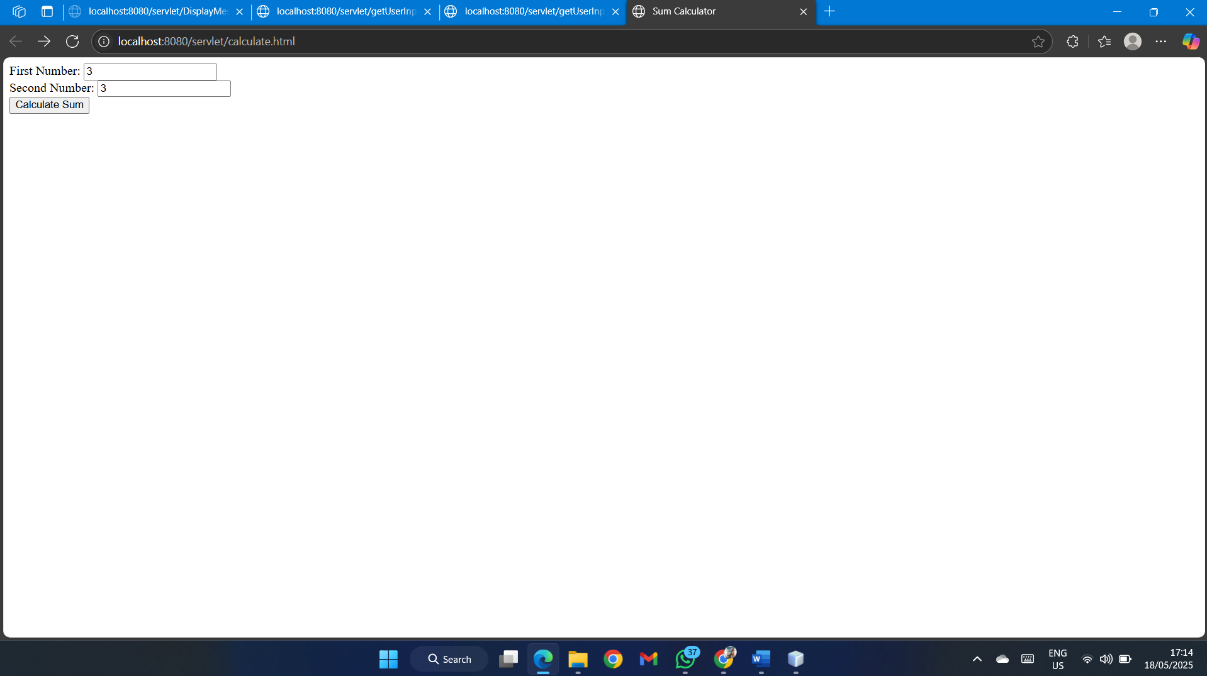

 Create a Servlet (CalculateSumServlet) to calculate the sum of the numbers and display the  result.

package com.example;

import java.io.IOException;

import java.io.PrintWriter;

import javax.servlet.ServletException;

import javax.servlet.annotation.WebServlet;

import javax.servlet.http.HttpServlet;

import javax.servlet.http.HttpServletRequest;

import javax.servlet.http.HttpServletResponse;

@WebServlet("/calculateSum")

public class CalculateSumServlet extends HttpServlet {

@Override

protected void doPost(HttpServletRequest request, HttpServletResponse response)

throws ServletException, IOException {

int num1 = Integer.parseInt(request.getParameter("num1"));

int num2 = Integer.parseInt(request.getParameter("num2"));

int sum = num1 + num2;

response.setContentType("text/html");

PrintWriter out = response.getWriter();

out.println("<html><body>");

out.println("<h1>The sum of " + num1 + " and " + num2 + " is: " + sum + "</h1>");

out.println("</body></html>");

} }

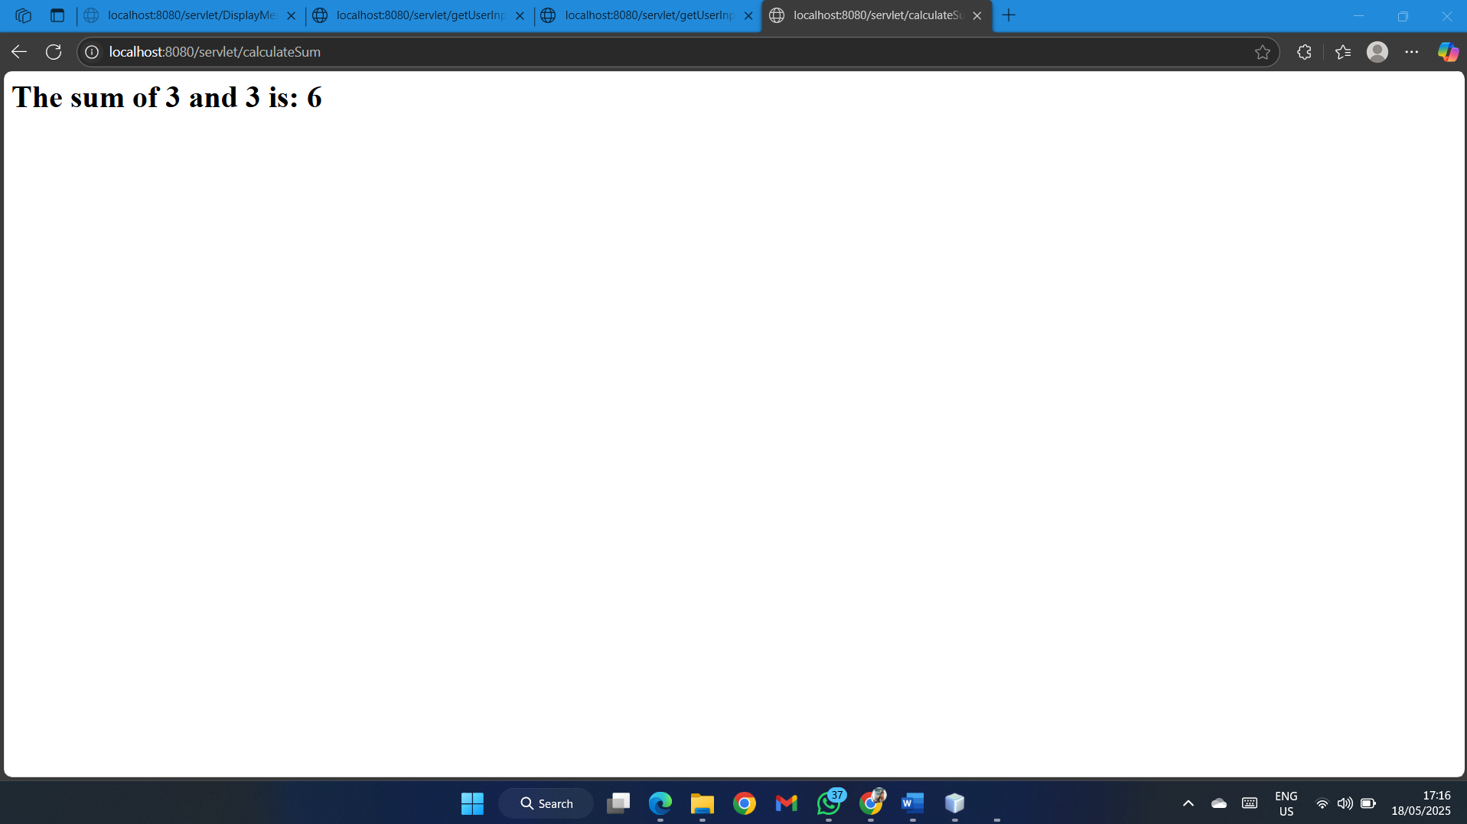

 Lab Task 4: Java Servlet with Database CRUD Operations

1. **Set up a database** with a table named stock (fields: id, product_name, quantity).

CREATE DATABASE stock_management;

USE stock_management;

CREATE TABLE stock (

id INT AUTO_INCREMENT PRIMARY KEY,

 product_name VARCHAR(255),

 quantity INT

);

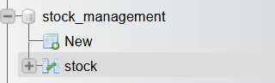

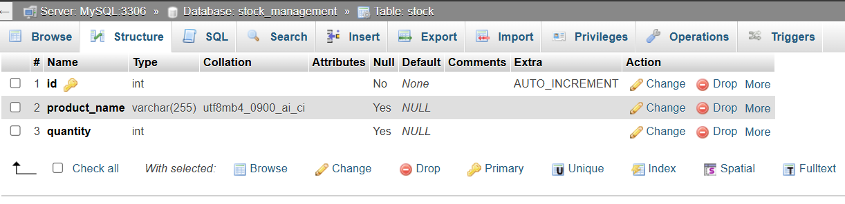

**HTML Form (stockForm.html)**

<!DOCTYPE html>

<html>

<head><title>Stock Management</title></head>

<body>

 <h2>Manage Stock</h2>

 <form action="stockAction" method="POST">

 Product Name: <input type="text" name="product_name" required><br>  Quantity: <input type="number" name="quantity" required><br>  <input type="submit" name="action" value="Add Product">  <input type="submit"

name="action" value="Update Product">  <input type="submit" name="action" value="Delete Product">  </form>

</body>

</html>

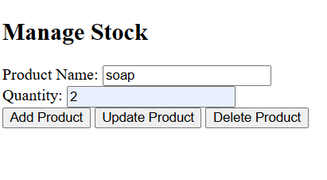

**Servlet Code (StockManagementServlet.java)**

import java.io.IOException;

import java.io.PrintWriter;

import java.sql.*;

import javax.servlet.ServletException;

import javax.servlet.annotation.WebServlet;

import javax.servlet.http.HttpServlet;

import javax.servlet.http.HttpServletRequest;

import javax.servlet.http.HttpServletResponse;

@WebServlet("/stockAction")

public class StockManagementServlet extends HttpServlet {

 private Connection getConnection() throws SQLException {  String url = "jdbc:mysql://localhost:3306/stock_management";  String username = "root";

 String password = "root"; // replace with your database password  return DriverManager.getConnection(url, username, password);  }

 protected void doPost(HttpServletRequest request, HttpServletResponse  response)

 throws ServletException, IOException {

 String action = request.getParameter("action");

 String productName = request.getParameter("product_name");  int quantity = Integer.parseInt(request.getParameter("quantity"));

 try (Connection conn = getConnection()) {

 switch(action) {

 case "Add Product":

 try (PreparedStatement stmt = conn.prepareStatement(  "INSERT INTO stock (product_name, quantity)  VALUES (?, ?)")) {

 stmt.setString(1, productName);

 stmt.setInt(2, quantity);

 stmt.executeUpdate();

response.getWriter().write("<h1>Product Added

Successfully</h1>");

 }

break;

 case "Update Product":

 try (PreparedStatement stmt = conn.prepareStatement(  "UPDATE stock SET quantity = ? WHERE product_name  = ?")) {

 stmt.setInt(1, quantity);

stmt.setString(2, productName);

 stmt.executeUpdate();

response.getWriter().write("<h1>Product Updated

Successfully</h1>");

 }

break;

 case "Delete Product":

 try (PreparedStatement stmt = conn.prepareStatement(  "DELETE FROM stock WHERE product_name = ?")) {  stmt.setString(1, productName);

stmt.executeUpdate();

 response.getWriter().write("<h1>Product Deleted  Successfully</h1>");

 }

break;

 default:

 response.getWriter().write("<h1>Invalid Action</h1>");  }

 } catch (SQLException e) {SLIATE HNDIT ENTERPRISE ARCHITECTURE 2 YEAR -2 SEMESTR

 e.printStackTrace();

 response.getWriter().write("<h1>Database Error: " +  e.getMessage() + "</h1>");

 }

 }

}

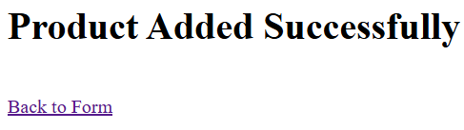

Top of Form

Bottom of Form